YOU ARE HISTORY

Published in the Star Tribune Variety Section on Wednesday, May 13, 2020

Archivists are asking for blog posts, photos, signs, even T-shirts to capture pandemic history as it’s happening.
By RICHARD CHIN • richard.chin@startribune.com
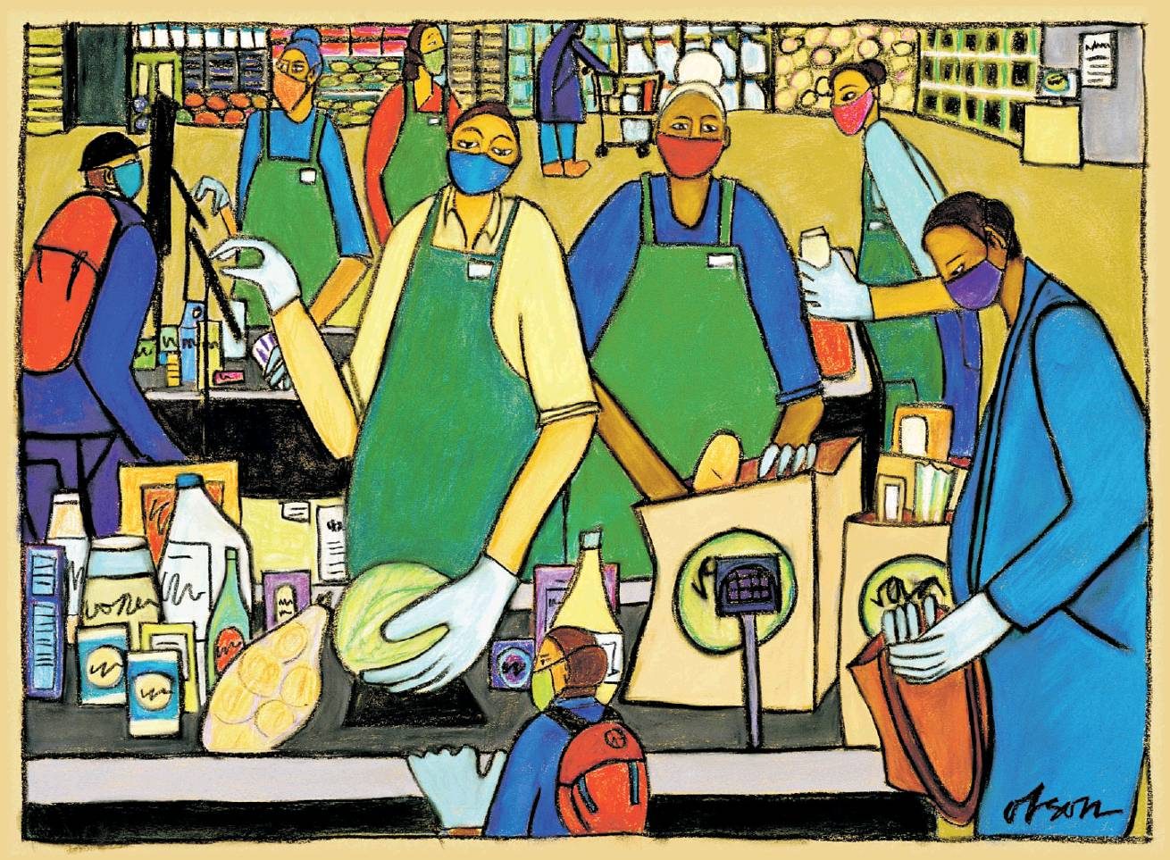
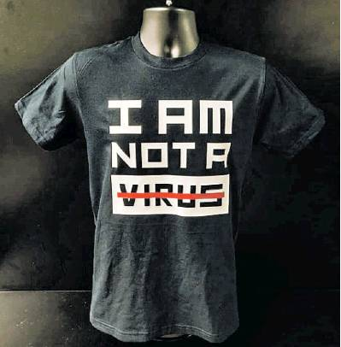
Carolyn Sue Olson’s illustration from her “Essential Workers” series, top, depicts masks that are becoming our new normal. Sai Xiong’s “I AM NOT A VIRUS” shirt speaks out against anti-Asian bias that has occurred. Both pieces have been collected by the Minnesota Historical Society.

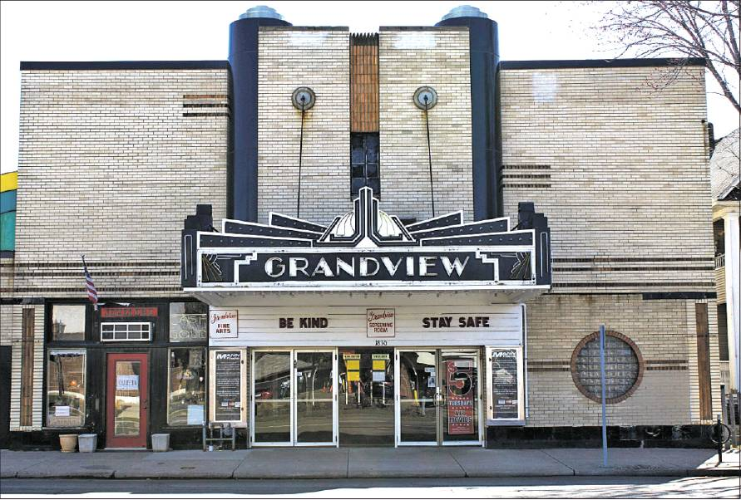
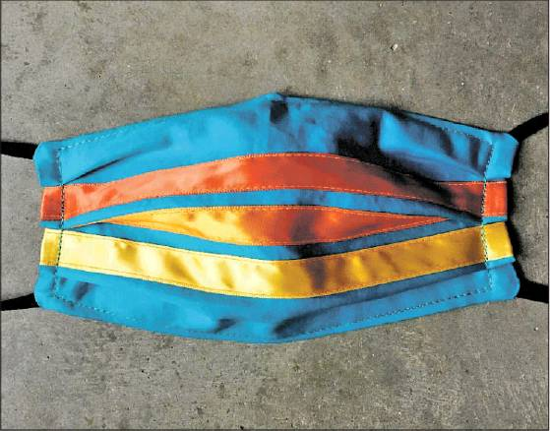
Photos provided by Audrey Kludtke, Maggie Thompson, Mary Warner Audrey Kludtke’s photo of the marquee of the closed Grandview movie theater in her neighborhood of St. Paul and a cloth mask designed by artist Maggie Thompson to reflect her Ojibwe heritage were included in the Minnesota Historical Society’s History Is Now website documenting the impact of the coronavirus on the state. The Morrison County Historical Society has been collecting images of COVID-related business signs.
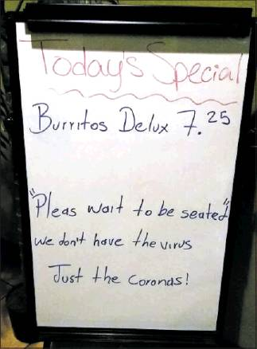
Decades from now, historians may look back at 2020 and say that was the year that we stopped shaking hands.
Or the year that working from home became the norm.
Or the year Americans stopped being squeamish about bidets.
History is always happening, of course, but it’s clear that we’re cursed to be living in particularly interesting times, so interesting that they may become a watershed, a dividing line of our lives: before the pandemic, after the pandemic.
That’s why historians around the state and the country aren’t waiting to begin documenting the impact of this global crisis.
While the pandemic has been raging, curators, historians and archivists at institutions from the Minnesota Historical Society to Carleton College have been gathering blog posts, journal entries, photographs, drawings, videos and artifacts like handmade masks and T-shirts.
It’s part of a relatively recent trend to document history as it’s happening and to widely cast the net, capturing the experiences of ordinary people in extraordinary times.
Historians are encouraging regular folks, even kids, to record and contribute their thoughts via e-mail, digital scrapbooks or online questionnaires.
The Douglas County Historical Society suggests taking its “COVID-19 Self-History Interview,” in which you answer questions like “What am I afraid of?” “How have I adapted my life so far?” “What are my hopes for the future?”
In Morrison County, the historical society’s website recommends keeping a candid coronavirus journal, adding, “If you use humor to cope, including gallows humor, make note of it — don’t let people in the future assume we’re all puritanical saints.”
The Carleton College website notes we are all eyewitnesses to history, that the pandemic affects us all. “There is no need to worry whether you are original, witty, or stylish. You are simply recording parts of your daily life; future historians will appreciate your honesty,” it reads.
“There’s not a single person who’s living the life we were living two months ago. Nobody,” said Serena Zabin , a Carleton College history professor. “Those are things we only know if we write them down now.”
In the 1970s and 1980s, historians started to pay more attention to the voices of common people, not just the writings and records of the rich, powerful or famous, Zabin said.
Social upheavals like the civil rights and the women’s equality movements helped drive that impulse, as did the artifacts left by visitors to the Vietnam Veterans Memorial Wall in Washington, D.C., and at impromptu memorials created after the Oklahoma City bombing and the Sept. 11 attacks.
The concept of collecting “oral histories” from people previously not considered worthy of a history book also started in this part of the 20th century, said Ryan Barland , an oral historian from the Minnesota Historical Society.
In recent years, the Minnesota Historical Society has collected material during the Republican National Convention in St. Paul in 2008 and the Women’s March in January 2017.
After Prince died in 2016, the Historical Society collected the tributes that people wrote on Post-it notes and left near an exhibit of the outfit the performer wore in “Purple Rain.”
It also collected wedding photos when same sex marriage became legal in Minnesota on Aug. 1, 2013.
To document the pandemic, the Historical Society has acquired a turquoise cloth mask sewn by Twin Cities textile artist Maggie Thompson decorated with red, orange and yellow ribbons symbolizing her Ojibwe heritage.
It’s also purchased a T-shirt designed by Sai Xiong , a St. Paul artist and founder of Povhaum Studio. His shirt, which has the message “I AM NOT A VIRUS” written across the front, was designed in response to anti-Asian bias that occurred as the pandemic spread around the world.
“I was caught by surprise that they reached out to me,” Xiong said. “At first I didn’t know what they meant when they said it would be historical.”
The Historical Society also recently purchased a pastel drawing by Duluth artist Carolyn Sue Olson depicting a scene in a grocery store in which everyone is wearing masks and gloves.
In a description on the Historical Society’s History Is Now website, Olson said the drawing was inspired by her daughter’s job as a grocery store cashier in the Twin Cities.
It’s the first in a series of pieces Olson is creating called “Essential Workers,” depicting bus drivers, mail carriers, doctors, nurses, janitors, farm workers and trash collectors on the job during the pandemic.
The image of people wearing masks to perform an everyday task “was such a profound piece,” said Historical Society art curator Brian Szott , who said he could envision the drawing being used in a history book years from now.
“This is an image that suddenly has entered our consciousness,” he said.
E-mails and ephemera
Other attempts to preserve the essence of what’s happening now are occurring at the University of Minnesota, where web crawlers are saving websites and mass e-mails to document the university’s response to the pandemic, according to Erik Moore , head of the university archives.
Mary Warner , executive director of the Morrison County Historical Society, is saving things like city water bills with warnings against flushing anything down the toilet besides toilet paper. She’s also going around town taking pictures of the closed signs that businesses have had to post on their doors.
“We had to put one on our own museum,” she said.
The historians are hoping to preserve some of the things that will tell the story of the pandemic, things that might disappear or get thrown away when it’s all over: a photo of a chalk drawing, a screen shot of a Zoom meeting, a sign in a grocery store limiting toilet paper purchases.
In the future, a bottle of home-brewed hand sanitizer could become a museum piece.
“That would be the kind of object that would be fabulous 100 years from now to open in a box to find,” Zabin said.
Don’t be Minnesota modest
To get people to participate, the curators and archivists say they need to overcome the modesty of Minnesotans who doubt they’re important enough to merit the attention of a future historian or researcher.
“It’s not your responsibility to make sense of the historical importance of your own life,” Zabin said.
If you’re self-conscious about sharing, sites like the Carleton Covid-19 Archive can give you the option to keep your submissions sealed from scholars or the public for up to 50 years.
Even if it doesn’t end up in a museum or an archive, your family will probably appreciate having your oral history, your journal or your experiences recorded after you’re gone.
And it’s not just the family matriarch who should contribute.
In critical times, what children are thinking or feeling is also valuable to record, Zabin said. That’s the sort of thing that’s often most lacking in historical archives, but can be just as telling and powerful as the stories of adults.
Think of how much poorer we would be if a bored adolescent, cooped up with her family in enforced isolation, didn’t write down her thoughts in what we now know of as the diary of Anne Frank.
“Most of us fall into that category of common or ordinary people,” said Kent Whitworth , director and CEO of the Minnesota Historical Society. “History matters. But more important, my history and your history matters.”
Richard Chin • 612-673-1775

